**Network Fundamentals Week 6 Log Book**

**Summary**

We finished off the second part of the throughput exercise that we started the week before. We used some of the values from last week to generate some signal ratings for different time intervals. To do this we had to work out Time, S(t), Phase Delay, Bandwidth, Attenuation, Noise, and the Final S(t).

**Implementation**

We made use of Microsoft excel to produce a spreadsheet that would give us the numbers we needed and allowed us to manipulate data and make it easier to work out the values for each thing.

For time we use any sensible interval that will give us enough results, in this case we added 0.0007 each time

For the signal, S(t) we used the formula =10.5*SIN(100*PI()*Time)+8.25*SIN(200*PI()*Time)+6.5*SIN(300*PI()*Time)

For the phase delay we used the formula =10.5*SIN(100*PI()*Time +PI()/8)+8.25*SIN(200*PI()*Time +PI()/4)+6.5*SIN(300*PI()*Time +PI()/2)

For the bandwidth we used the formula =10.5*SIN(100*PI()*Time +PI()/8)+8.25*SIN(200*PI()*Time +PI()/4) This is basically the same as the previous formula but the last part has been cut off. This is because the last represents a frequency of 150Hertz (check the 3 frequencies from last weeks’ logbook) were as the bandwidth limit of the cable is 120Hertz. This means the last frequency cannot pass through the cable and will therefore not be included in the equation.

For the attenuation we used =bandwidth*10^(-10/20) where the power attenuation is -10dB in the throughput worksheet

Noise is randomly generated using the formula =RAND()*(2.5-(-2.5))+(-2.5) This means that a random number will be generated that is within the range of 2.5 and -2.5.

The Final signal, Final S(t), is worked out via attenuation + noise

**Results**

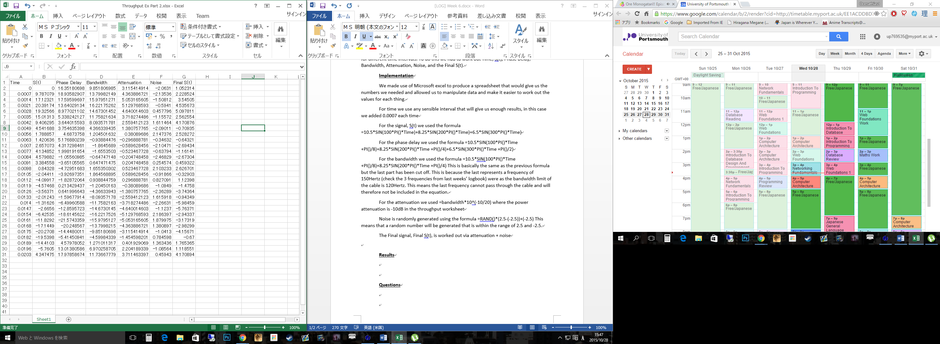

We needed to find the time domain of the signal. To get this we produce a line graph. The time domain is the original signal and final signal on the vertical axis and time on the horizontal axis. This gives us the follow line graph.

**Questions**

-Compare the original signal to each element in the spread sheet: e.g. Phase delay, bandwidth, etc

- illustrate with a graph for each element

-Explain what is happening to the original signal and discuss why?

**Conclusion**

We managed to apply 4 different constraints on the signal that would normal affect signal strength. This shows a simulation of real world signals being affected during communication. The time domain graph gives a good indication as to how badly the signal is affected by these different constraints.